# What is Weather data set?

Typical meterological year

A TMY is a data set of hourly values of solar radiation and meteorological elements for a 1-year period. It consists of months selected from individual years and concatenated to form a complete year. Because of the selection criteria, TMYs are not appropriate for simulations of wind energy conversion systems.

A TMY data is not necessarily a good indicator of conditions over the next year, or even the next 5 years. Rather, it represents conditions judged to be typical over a long period of time, such as 30 years. Because they represent typical rather than extreme conditions, they are not suited for designing systems and their components to meet the worst-case conditions occurring at a location. (User's Manual for TMY2s)

* TMY data sets derived from the 1953 - 1975 National Climatic Data Centre (NCDC), for 26 stations.
* TMY2 data sets derived from the 1961-1990 National Solar Radiation Data Base (NSRDB), for 239 stations.
* TMY3 data sets derived from the 1961-1990 and 1991-2005 National Solar Radiation Data Base (NSRDB), for 1020 stations.

# What is Weather file?

All building programs require a means of representing local climate conditions for their building models. For example radiance require the description of sky conditions to calculate luminance in space and energy simulation softwares like eQuest, Design Builder and EnergyPlus require mainly temperature, humidity and illuminance levels to simulate the response of a building. Each software requires a different format of weather data. For example eQuest requires data in .bin format, EnergyPlus and ESP-r requires .epw.

# EPW: U.S. Department of Energy

In .epw file all the data is in SI units. The format is text based and comma-separated. Actually the TMY2 data has been rearranged to facilitate visual inspection of data. The new data file format contains commas to facilitate data reading and analysis with spreadsheet programs. It has also made possible to change weather files as it can be easily edited in any spreadsheet programs. Another difference between these two formats is that .epw has two new data fields – minute and infrared sky. The minute field allows the use of data measured at intervals of less than one hour. This is usually required for some research study of energy efficiency for a particular building. This field also allows better calibration of energy model than possible in past. The new infrared sky field the program to calculate the effective sky temperature for night time energy calculations.

# Format of a .epw File

We use the EnergyPlus data dictionary format to describe the E/E weather data set. (See the end of this document). Each line in the format is preceded by a keyword such as LOCATION, DESIGN CONDITIONS, followed by a list of variables beginning either with A or N and a number. A stands for alphanumeric; N for numeric. The number following A/N is the sequence of that number in the keyword list. Commas separate data. (Refer to the IDD Conventions document in “Getting Started” for further explanation of the format). The header information consists of eight lines (keywords): LOCATION, DESIGN CONDITIONS, TYPICAL/EXTREME PERIODS, GROUND TEMPERATURES, HOLIDAYS/DAYLIGHT SAVINGS, COMMENTS 1, COMMENTS 2, and DATA PERIODS. This is followed by the time step data.

The first eight lines or header within each E/E weather file define basic location information such as longitude, latitude, time zone, elevation, annual design conditions, monthly average ground temperatures, typical and extreme periods, holidays/daylight savings periods, and data periods included. There is also space for users to document any special features or information about the file such as sources of data. The data then follows—8760/8784 lines if hourly data for a year. The specific data elements in the E/E format include:

* Location (City, State Province Region, Country, Data Source, WMO Number, Latitude, Longitude, Time Zone, Elevation)
* Design Conditions (Annual Extreme Daily Mean, Mean Maximum Dry Bulb Temperature and Standard Deviation, Mean Minimum Dry Bulb Temperature and Standard Deviation, Heating Dry Bulb Temperature (99.6%, 99%, 98%), Cooling Dry Bulb Temperature/Mean Coincident Web Bulb Temp (0.4%, 1.0%, 2.0%), Cooling Dew Point Temperature, Mean Coincident Dry Bulb Temp (0.4%, 1.0%, 2.0%), Coincident Humidity Ratio and Relative Humidity (0.4%, 1.0%, 2.0%), Daily Range of Dry Bulb Temperature, Heating Degree Days Base Temperature, Heating Degree Days, Cooling Degree Days Base Temperature, Cooling Degree Days)
* Typical/Extreme Periods (Number of Typical/Extreme Periods (up to 8), Description of each Typical/Extreme Period, Start Month/Day, End Month/Day)
* Ground Temperatures (Number of Ground Temperature Depths (up to 3), Depth for each Ground Temperature set, Soil Conductivity, Soil Density, Soil Specific Heat, Monthly Average Ground Temperatures)
* Leap Year indicator, Daylight Savings Periods, Holidays
* Comments
* Time Step Data Periods, #Number, #Number Records/Intervals in an hour, Description, Start Day of Week, Start Month/Day, End Month/Day)
* Time Step Data (Year, Month, Day, Hour, Minute), Data Source and Uncertainty Flags,
* Time Step Data (Dry Bulb Temperature, Dew Point Temperature, Relative Humidity, Atmospheric Station Pressure, Radiation (Extraterrestrial Horizontal, Extraterrestrial Direct Normal, Horizontal Infrared Radiation from Sky, Global Horizontal, Direct Normal, Diffuse Horizontal), Illuminance (Global Horizontal, Direct Normal, Diffuse Horizontal, Zenith Luminance), Wind (Direction, Speed), Sky Cover (Total, Opaque, Visibility, Ceiling Height), Present Weather (Observation, Codes), Precipitable Water, Aerosol Optical Depth, Snow (Depth, Days Since Last Snowfall))

Tables 2, 3, 4, 5, and 6 describe the codes for the sixth field in the time step data—Data Source and Uncertainty Flags. Table 2 describes the flags in order they are presented within the sixth data field—each flag is a single letter or number. Tables 3, 4, 5 and 6 provide a description of each of the codes. An example header and first and last days of an E/E data file for Washington, DC (Dulles Airport, Sterling, Virginia) is shown following the IDD description at the end of this document.

# Downloading EPW’s

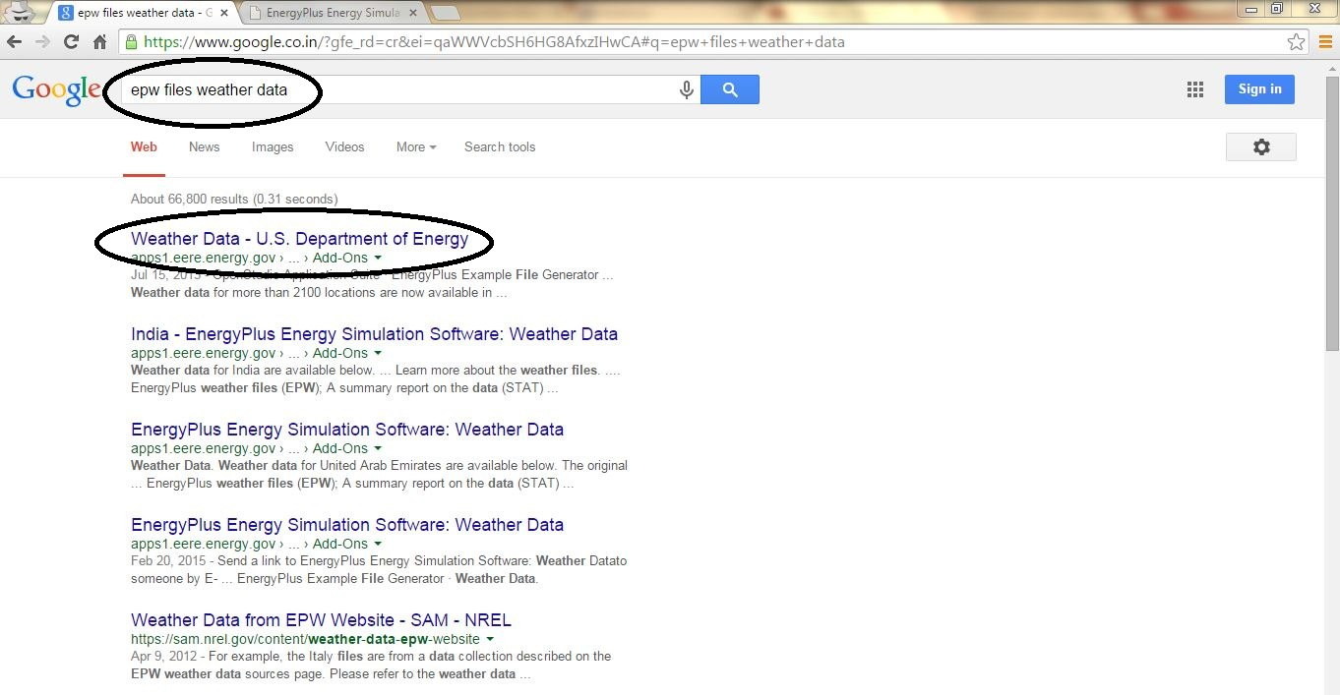

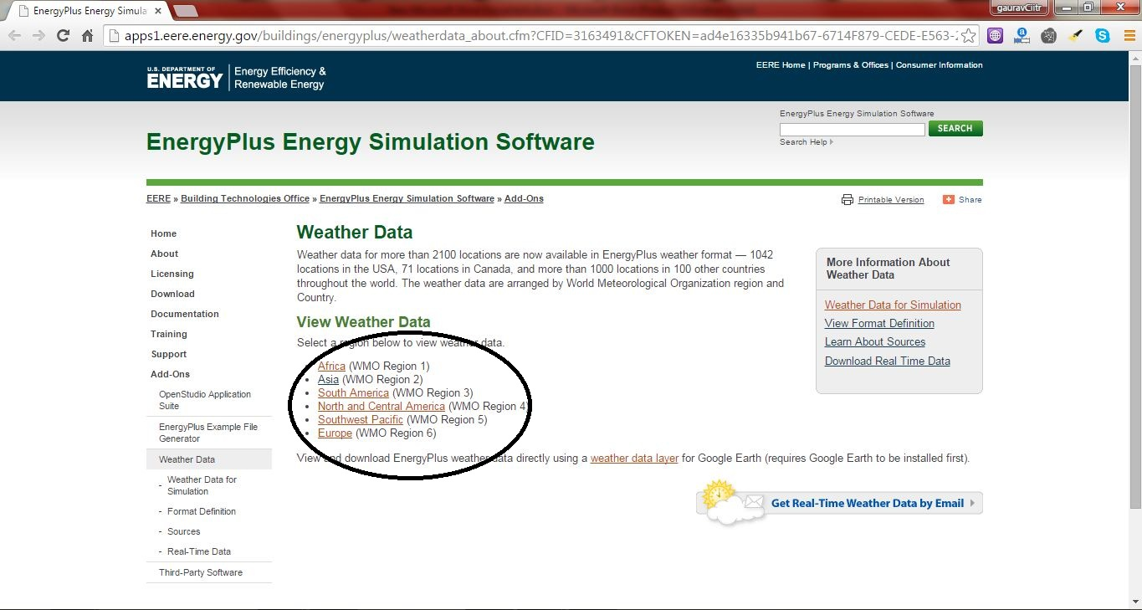

Each file is named using the ISO standard three-letter country abbreviation (i.e. IND for INDIA), followed by the location name, World Meteorological Organization designation (WMO) and the source format (CTZ2, CWEC, CityUHK, CSWD, CTYW, ETMY, IGDG, IMGW, IMS, INETI, ISHRAE, ITMY, IWEC, KISR, NIWA, RMY, SWEC, SWERA, or TMY3). Thus, IND_New.Delhi.421820_ISHRAE.epw — is the EnergyPlus weather file (EPW) from the Indian Weather Data from the Indian Society of Heating, Refrigerating and Air-Conditioning Engineers (ISHRAE) data for New Delhi, India, WMO 421820.

There are three files associated with each location: EnergyPlus weather files (EPW), a summary report on the data (STAT), and a compressed file (ZIP) which contains the EPW, STAT, and DDY (design conditions) files for the location. Note: all IWEC files only have STAT and ZIP files.

# Climate Consultant 4

It was developed by the Department of Architecture and Urban Design, University of California, Los Angeles. Graphically displays climate data in either metric or imperial units in dozens of ways useful to architects.

Benefits

* Easier to identify unique patterns and subtle details that characterize each different climate.
* Thresholds and comfort zones are more flexible.
* In contrast to The Weather Tool, detailed technical information about the passive strategies criteria is documented and freely available.
* The “Wind Wheel” graphics shows velocity and direction correlated with temperature and humidity, and can be animated hourly or daily or monthly.
* The psychrometric analysis recommends the most appropriate passive design strategies as outlined in Givoni’s Man Climate and Architecture.

Climate Consultant 4 is free to download from the website http://www.energy-design-tools.aud.ucla.edu/

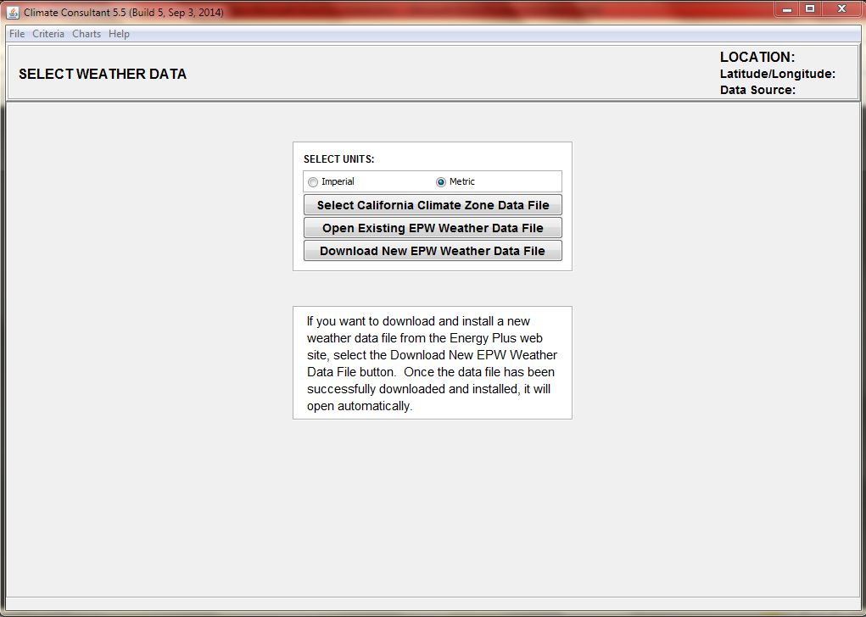

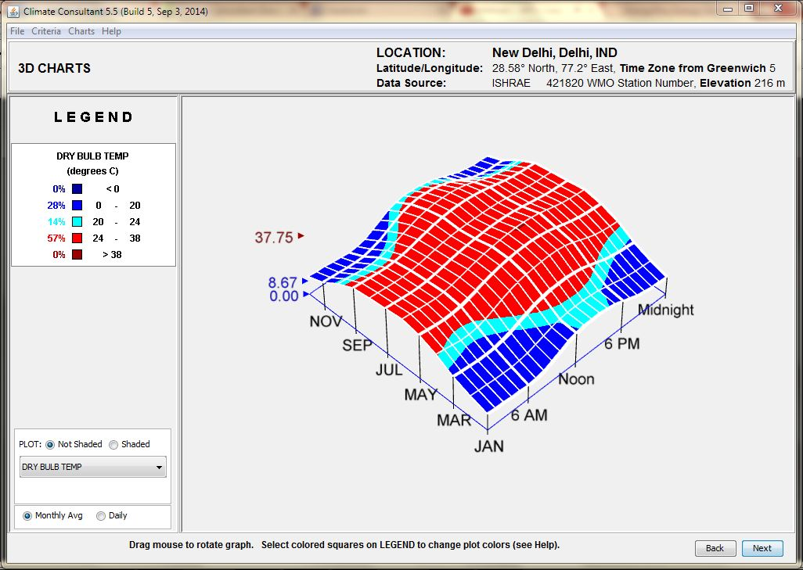

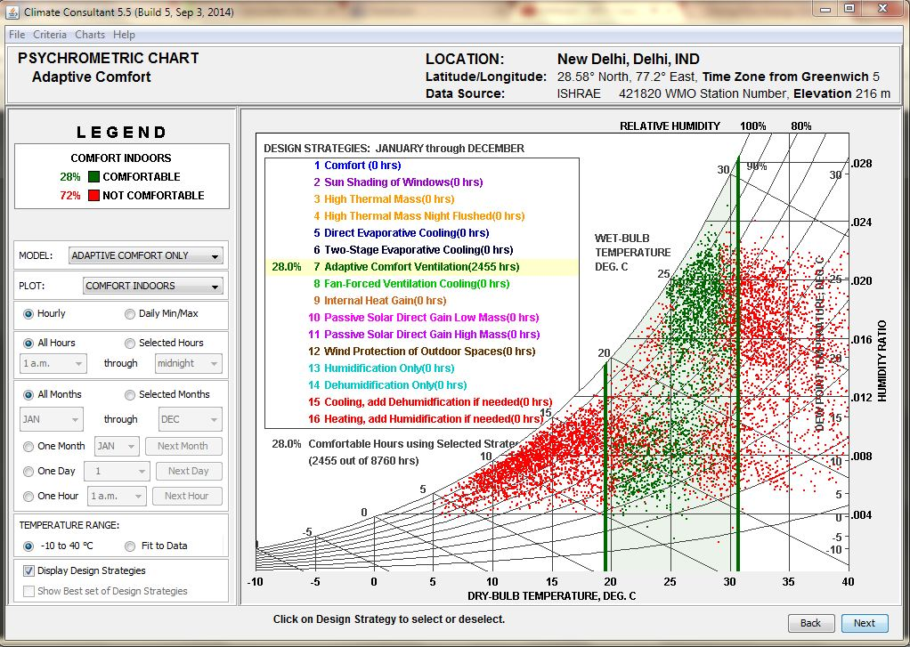

# Surrogate City Finder

It is developed by the Centre for IT in Building Science (CBS), International Institute of Information Technology, Hyderabad, India. This is a web based tool that that shortlists the best-matched weather based on parameters such as the latitude, altitude, and temperature range.

The SCF tool has been tested by analysing the annual energy consumption of 16- reference building models simulated for eight locations from different international climate zones and their surrogate cities to find that the deviation in annual energy consumption was mostly within the range of ±2%.

The tool can be accessed from [cityfinder.cbs.iiit.ac.in](www.cityfinder.cbs.iiit.ac.in)

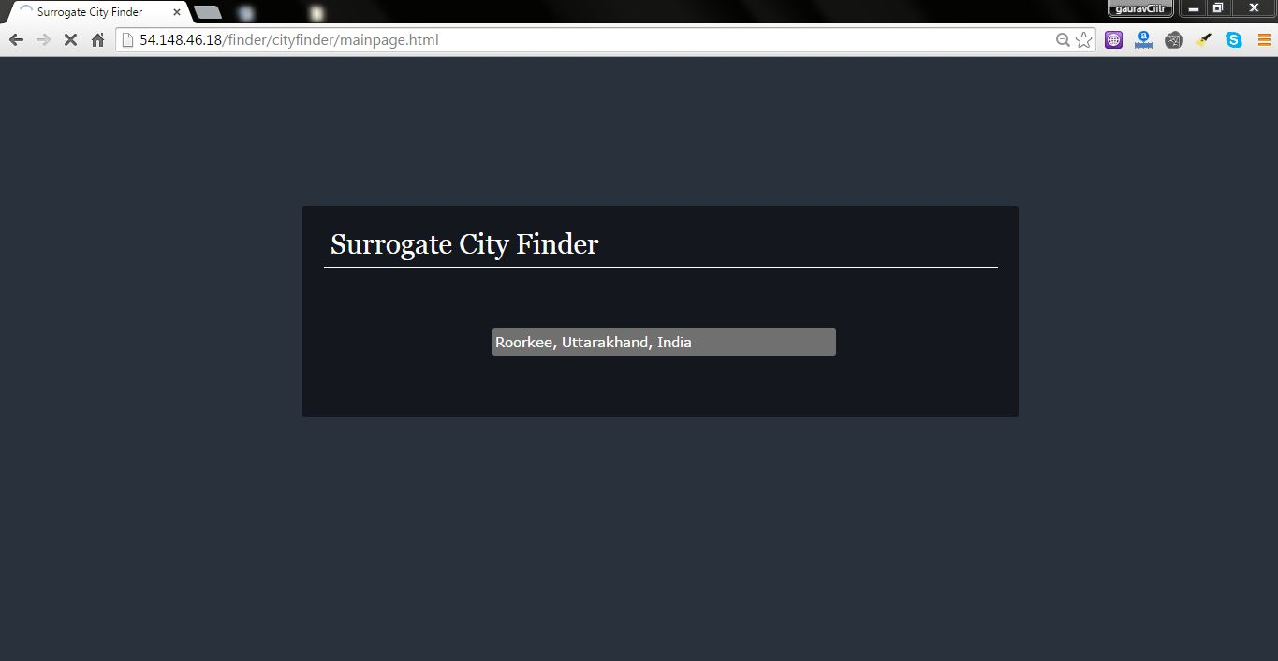

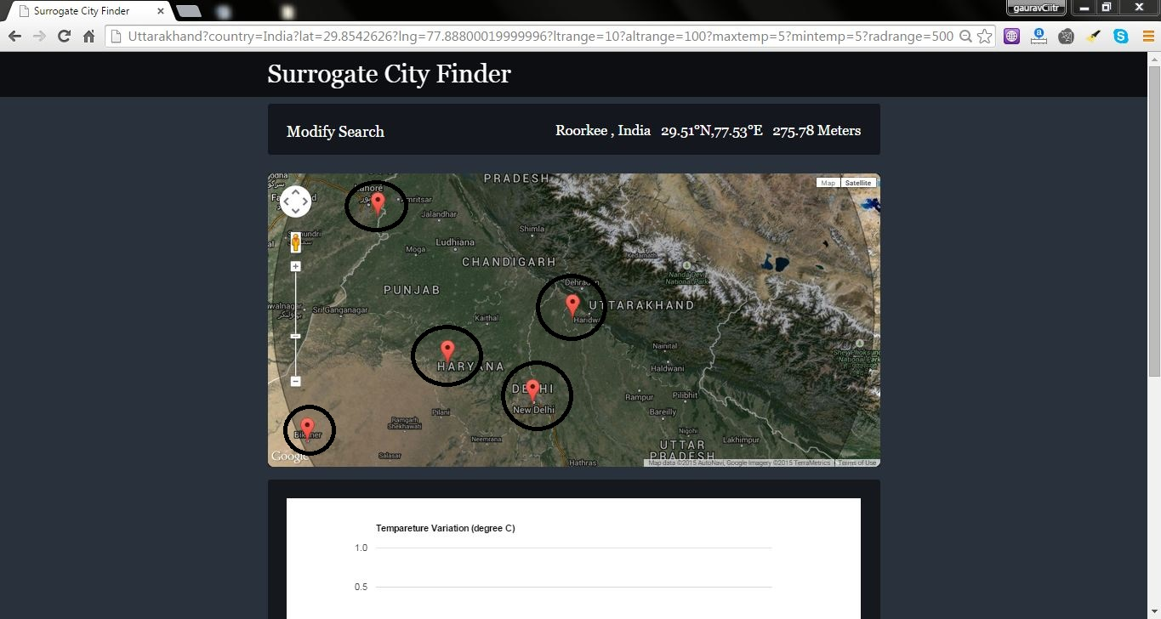

# DView

DView is used by BEopt for visualizing time-series weather data at any timestep (e.g., hourly or sub-hourly). DView opens CSV files and also recognizes several weather data file formats, including TMY2, TMY3, and EPW files.

The Hourly, Daily, and Monthly graphs allow you to turn variables on or off with a single click, and to zoom and pan very easily. DView has the ability to display simultaneous line and stacked areas as demonstrated in the Hourly graph below. 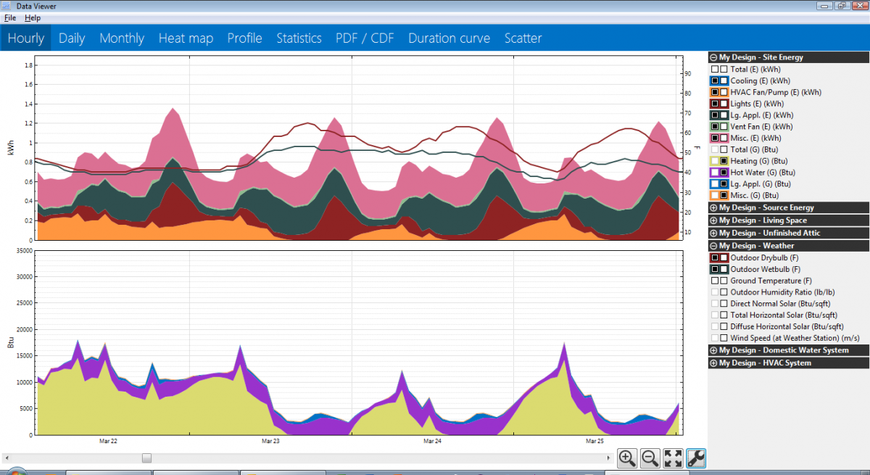

Daily and Monthly time series graphs are automatically created by averaging or summing the hourly data:

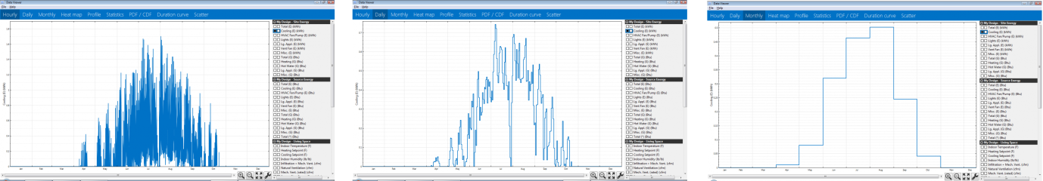

DView is free to download from the website <https://beopt.nrel.gov/downloadDView>

# Climate Classification

The initial contributors to climate classification are astronomers and ancient Greeks who have provided literature of consideration of climatic variation over the world. The ancient Greeks identified three classes, five zone system by knowledge of the Sun travel. These zones are – one Torrid Zone, two Temperate zones and two Frigid zones. These are the single variable climate classification. There are several other attempts have been done in the field of climate classification. It is not possible to include all variation in this study of climate classification. Some of them whom are widely spread over the world and used for classification of world climate are discussed in following section.

# [1] Koppen-Geiger Classification

The first quantitative classification of world climates was presented by the German scientist Wladimir Koppen (1846-1940) in 1900; it has been available as world map which later updated in 1954 and 1961 by Rudolf Gieger (1894-1981). Koppen was trained as a plant physiologist and realized that plants are indicators for many climatic elements. His effective classification was constructed on the basis of five vegetation groups. [5] The classification is strictly empirical and each climate is defined according to fixed values of temperature and precipitation. This system features a shorthand code of letters designating major climate groups and further subdivision to distinguish particular seasonal characteristics of temperature and precipitation. The following tables show climate classification and description of each climate zone.

Description of climate groups

|  |  |  |
| --- | --- | --- |
| Code | Type | Description |
| A | Tropical climate | * Monthly average temperature >18oC * No winter season * Strong annual precipitation (higher than evaporation) |
| B | Dry climate | * Annual evaporation higher than precipitations * No permanent rivers |
| C | Hot moderate climate | * The 3 coldest months average a temperature between -3oC and 18oC * Hottest month average temperature >10oC * The summer and winter season are well defined. |
| D | Cold moderate climate | * Coldest month average temperature of the coldest month < -3oC * Hottest month average temperature >10oC * The summer and winter seasons are well defined |
| E | Polar climate | * Average temperature of the hottest month >10oC * The summer season is very different from the rest of the year. |

Description of sub-group of main group

|  |  |  |
| --- | --- | --- |
| Code | Description | Applies to |
| S | * Steppe climate (semi-arid) * Annual precipitations range between 380 and 760mm | B |
| W | * Dry (arid and semi-arid) climates * Annual precipitations <250 mm | B |
| f | * Wet climate * Precipitations occur every month of the year * No dry season | A,C,D |
| w | * Dry season in winter | A,C,D |
| s | * Dry season in summer | C |
| m | * Monsoon climate * Annual precipitations >1500mm * Precipitations of the driest month <60 mm | A |
| T | * Average temperature of the hottest month between 0 and 10oC | E |
| F | * Average temperature of the hottest month <0 | E |
| M | * Abundant precipitation * Mild winter | E |

Description of sub-group of main group

|  |  |  |
| --- | --- | --- |
| Code | Description | Applies to |
| a: hot summer | * Average temperature of the hottest month >22oC | C,D |
| b: moderate summer | * Average temperature of the hottest month<22oC * The 4 hottest month average temperature >10oC | C,D |
| c:short and cold summer | * Average temperature of the hottest month<22oC * Monthly average temperature >10oC for less than 4 months * Average temperature of the coldest month >-38oC | C,D |
| d: very cold winter | * Average temperature of the coldest month <-38oC | D |
| h: dry and heat | * Annual average temperature>18oC | B |
| k: dry and cold | * Annual average temperature <18oC | B |

[2] ASHRAE (American Society of Heating, Refrigeration and Air-conditioning Engineers)

This climate classification is based on two parameters: air temperature and precipitation. The air temperature is defined as Cooling Degree Day (CDD) and Heating Degree Day (HDD). The degree-day essentially the summation of temperature differences over time, and hence they capture both extremity and duration of outdoor temperatures. The temperature difference is between a reference (base) temperature and the outdoor air temperature. This climate classification system uses cooling criteria (CDD 10o C) for the cooling dominated climates and heating criteria (HDD 18o C) for heating-dominated climates for zone division. A mixed cooling and heating zone defined by both criteria falls in between. This classification is defined by numeric numbers from 0 to 8 and letter (A, B, and C). The definitions of numbers and letters are:

Marine (C) definition- Locations meeting all four of the following criteria:

1. Mean temperature of coldest month between -3o C and 18o C;
2. Warmest month mean< 22oC;
3. At least four months with mean temperatures over 10oC;
4. Dry season in summer. The month with the heaviest precipitation in the cold season has at least three times as much precipitation as the month with the least precipitation in the rest of the year. The cold season is October through March in the Northern Hemisphere and April through September in the Southern Hemisphere.

Dry (B) definition—Locations meeting the following criteria:

1. Not Marine (C);
2. If 70% or more of the precipitation, P, occurs during the high sun period, then the Dry/Humid threshold is

1. If between 30% and 70% of the precipitation, P, occurs during the high sun period, then the Dry/Humid threshold is

1. If 30% or less of the precipitation, P, occurs during the high sun period, then the Dry/Humid threshold is

Where

P = annual precipitation in mm and

T = annual mean temperature in °C.

Summer or high sun period = April through September in the Northern Hemisphere and October through March in the Southern Hemisphere. Winter or cold season = October through March in the Northern Hemisphere and April through September in the Southern Hemisphere.

Humid (A) definition – Locations that are not marine and not dry.

ASHRAE climate zone criteria

|  |  |  |  |
| --- | --- | --- | --- |
| ASHRAE | Heating Degree Day (HDD 18 0C) | Cooling Degree Day (CDD 10 0C) | Climate Zone Number |
| Extremely Hot | - | 6000<CDD | 0 |
| Very Hot | - | 5000<CDD | 1 |
| Hot | - | 3500<CDD<=5000 | 2 |
| Warm | - | 2500<CDD<3500 | 3 |
| Warm-Marine | HDD<=2000 | CDD<=2500 | 3C |
| Mixed | HDD<=3000 | CDD<=2500 | 4 |
| Mixed-Marine | 2000<HDD<=3000 | - | 4C |
| Cool | 3000<HDD<=4000 | - | 5 |
| Cold | 4000<HDD<=5000 | - | 6 |
| Very Cold | 5000<HDD<=7000 | - | 7 |
| Subarctic | 7000<HDD | - | 8 |